Seminar:
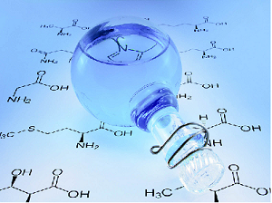
Friday, May 7th 2021, on line Seminar, Teams link, 15:00 h
(or) Aula A, DIFC, Via Archirafi 36, DIFC

Seminar Title
(JPEG; max 300 x 250)

Prof. XXX YYY, Department XXX, University YYY
Keywords: nanostructures, fluorescence, seminar
The abstract of the seminar can be viewed at the following link

